  Learn, Laugh and Play | Helsby Hillside Primary School  Bates Lane  Helsby  WA6 9LN  Tel: 01928 722991  Email: admin@hillside.cheshire.sch.uk  Headteacher: Mr C Richardson
8th June 2020

Dear Parent/Carer

General Data Protection Regulation GDPR - NHS Track and Trace Use Privacy Notice for Families
As children are beginning to return to school, we continue working hard to ensure the safety and wellbeing of all our children, staff and families. We have put measures in place within our school but we are very much aware our responsibilities continue outside the school gates.

A key part of the Government’s measures to manage coronavirus is the use of the NHS Track and Trace scheme. As with all schools, we hold a lot of data and we may, on occasions, need to share some of the data we hold on request from a member of the NHS Track and Trace team, Public Health Team or any other appropriate body.

As a school, we will share the requested data as part of our obligation to support the Government’s strategy. This means it is likely we will be asked to provide contact details if a case of coronavirus is either confirmed or suspected in our school.

We will be sharing this information on the basis of Public Duty. If we are required to share any health details, we will do this as it is necessary for the public interest.

Please be assured we will keep a record of any information we share.

If you have any questions, please do contact the school office.

NHS Track and Trace and the Law

Details on the use of the Track and Trace app, including what happens to the data collected, can be found at this dedicated website:

https://covid19.nhs.uk/
Please note: this notice should be read alongside our other GDPR and Data Protection notices available from our website.
Yours sincerely
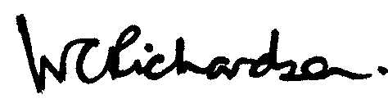
Craig RichardsonHeadteacher

